**Analytics Mock-up – Fund IRR**

User Log into Analytics and select **New**

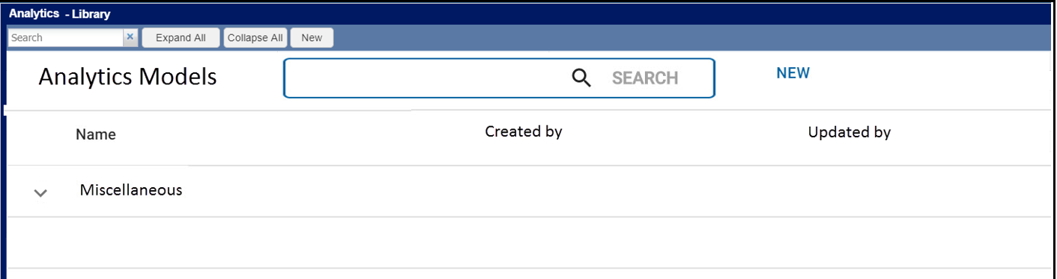

**Step 1** of the Build Analytics Model stepper is displayed. The user selects desired calculation, and selects **Next**.

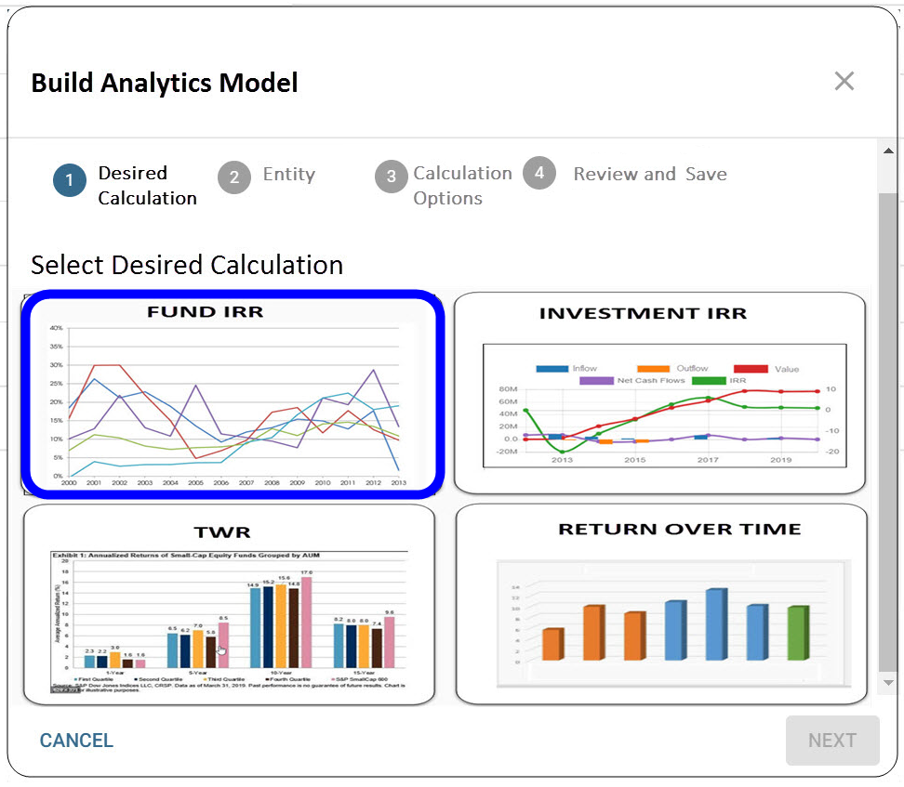

**Step 2** of the Build Analytics stepper is displayed. Selected Entity is displayed as Funds, user selects desired Funds and Class, then selects Next.

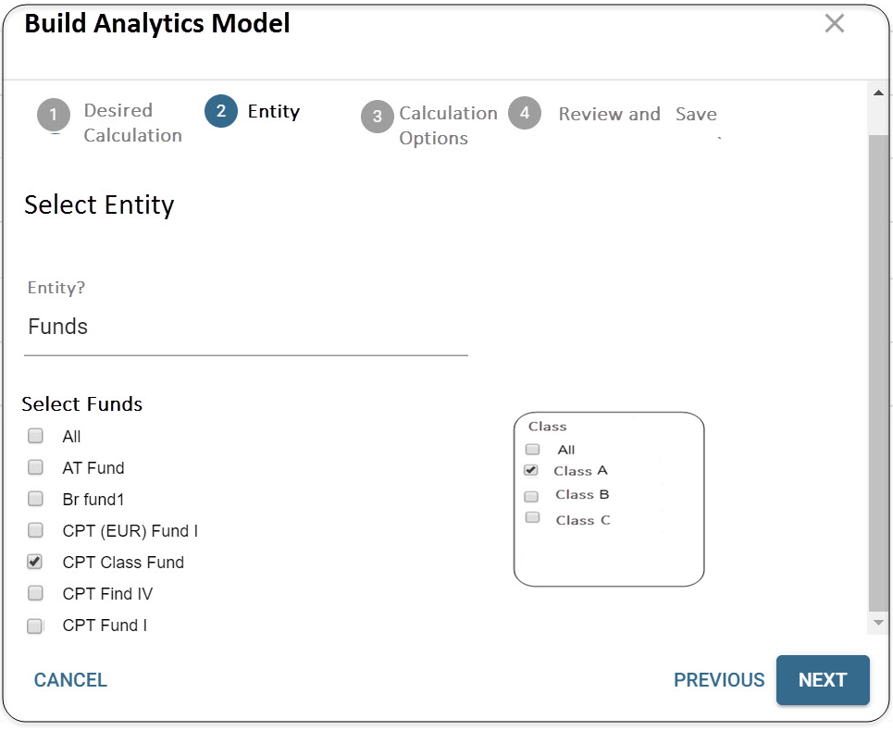

**Step 3** of the Build Analytics Model pops up. The user selects the desired Calculations Options and selects Run Calculation.

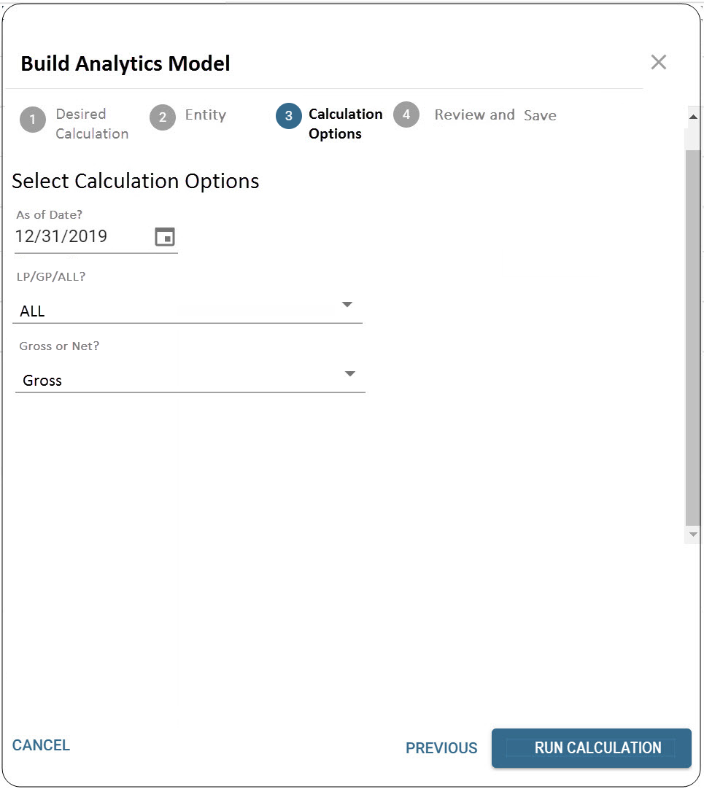

**Step 4** of the Build Analytics Model pops up. The results are displayed. User can also check the Cashflow flags to view the respective Data. User then selects ***Save*** to save the model.

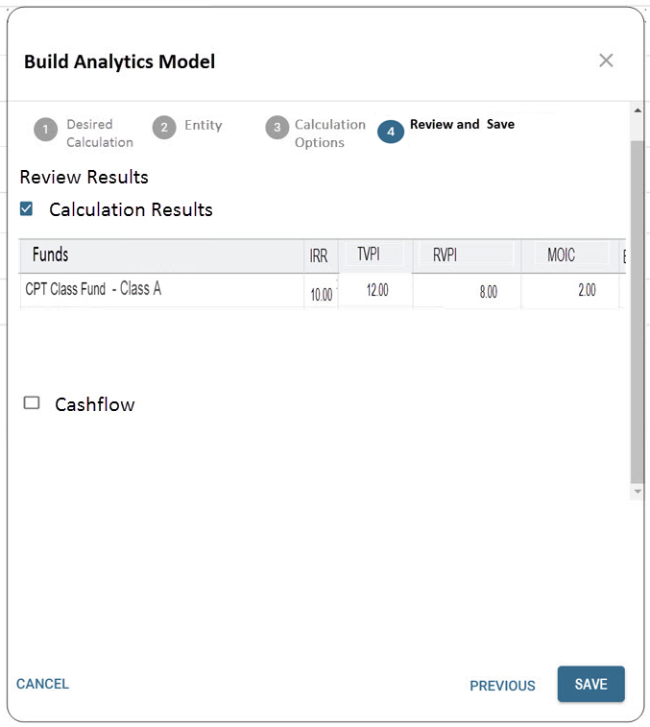

The Model is saved to the Library and the below widgets are displayed.

